**CHM 101A CA ASSIGMENT I**

**SOLUTION**

**MR. ABDULLAHI D. K.**

**QUESTION**

The rate of the following reaction in aqueous solution is monitored by measuring the number of moles of Hg2Cl2 that precipitate per liter per minute. The data obtained are listed in the table.

2 HgCl2(aq) + C2O42–(aq) → 2 Cl–(aq) + 2 CO2(g) + Hg2Cl2(s)

**Experiment [HgCl2] (M) [C2O42–] (M) Initial rate (mol L–1 min–1)**

1 0.105 0.15 1.8×10–5

2 0.105 0.15 1.8×10–5

3 0.052 0.30 7.1×10–5

4 0.052 0.15 8.9×10–6

(a) Determine the order of reaction with respect to HgCl2, with respect to C2O42– and overall.

(b) What is the value of the rate constant k?

(c) What would be the initial rate of reaction if [HgCl2] = 0.094 M and [C2O42–] = 0.19 M?

(d) Are all four experiments necessary to answer parts (a) - (c)? Explain.

### **Answer**

Use the method of initial rates to find the orders of reaction in each component. This will allow evaluation of the rate constant and the initial rate of reaction at any other condition.

(a) Rate = k[HgCl2]m[C2O42–]n

Compare the rates in experiments 1 and 2 (or 3 and 4) to find the order in oxalate ion:

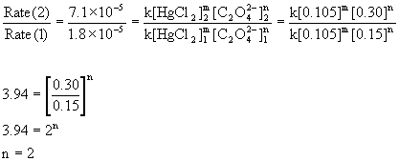

Compare the rates in experiments 2 and 3 (or 1 and 4) to find the order in mercury(II) chloride:

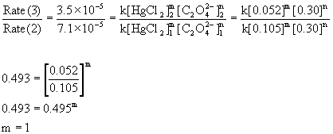

Therefore, the reaction is first order with respect to mercury(II) chloride and second order with respect to oxalate. The overall order is the sum of these, 2 + 1 = 3, third order.

(b) To find the rate constant, use the rate equation and solve for k:

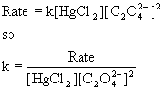

Experiment [HgCl2] (M) [C2O42–] (M) Initial rate (mol L–1 min–1)k

1 0.105 0.15 1.8×10–5https://www.chm.uri.edu/weuler/chm112/Image882.gif

2 0.105 0.15 1.8×10–5https://www.chm.uri.edu/weuler/chm112/Image883.gif

3 0.052 0.30 7.1×10–5https://www.chm.uri.edu/weuler/chm112/Image884.gif

40.0520.158.9×10–6https://www.chm.uri.edu/weuler/chm112/Image885.gif

The average k = 7.6×10–3 M–2min–1

(c) Rate = k[HgCl2][C2O42–]2

Rate = (7.6×10–3 M–2min–1) [0.094 M] [0.19 M]2 = 2.6×10–5 Mmin–1

(d) Since there are only two reactants, three experiments are the minimum required to find the rate equation and rate constant. Experiments 1 - 3 would have sufficed to answer the questions posed.